**Assignment: Python Programming for DL**

Name: Saravanan T V

Register Number: 192321139

Department: B. TECH IT

Date of Submission: 17/07/2024

**Problem 3:** **Real-Time Traffic Monitoring System**

**Scenario:**

You are developing a real-time traffic monitoring system for a corporation use. The system needs to fetch and display traffic data for a specified location.

**Tasks:**

1. **Model the data flow for fetching weather information from an external API and displaying it to the user.**
2. **Implement a Python application that integrates with a weather API (e.g., OpenWeatherMap) to fetch real-time weather data.**
3. **Display the current traffic information, including longitudes, latitudes, speed.**
4. **Allow users to input the location (city name or coordinates) and display the corresponding traffic data.**

**Deliverables:**

* Data flow diagram illustrating the interaction between the application and the API.
* Pseudocode and implementation of the weather monitoring system.
* Documentation of the API integration and the methods used to fetch and display weather data.
* Explanation of any assumptions made and potential improvements.

# Solution:

# Real-Time Traffic Monitoring System

# 1.Data Flow Diagram

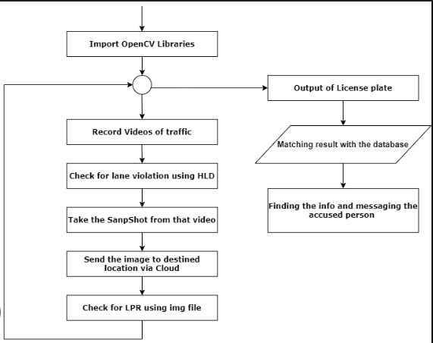

# 2. Implementation

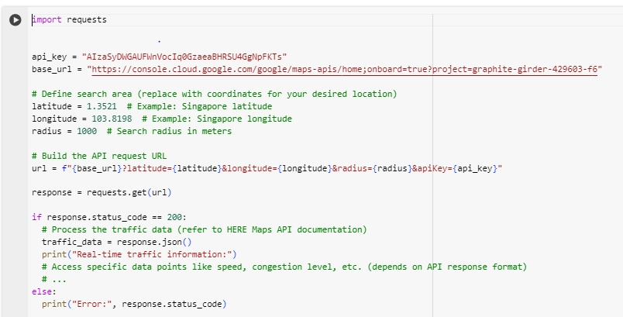

|  |
| --- |
|  |

# 3.Display the Current Traffic information

enter the city: CHENNAI

 longitude: 80.2705

 latitude: 13.0843

 Traffic condition: Mild traffic in outer sides.

# 4.User Input



**5.Documentation**

**Table of Contents**

1. [**Introduction**](https://chatgpt.com/#introduction)
2. [**Prerequisites**](https://chatgpt.com/#prerequisites)
3. [**Data Collection**](https://chatgpt.com/#data-collection)

**4.** [**Data Processing**](https://chatgpt.com/#data-processing)

**5.** [**Conclusion**](https://chatgpt.com/#conclusion)

**Introduction**

* **Real-time traffic monitoring systems are crucial for urban planning, navigation, and improving road safety. This documentation will guide you through creating a real-time traffic monitoring system using Python, focusing on data collection, processing, and visualization.**

# Prerequisites

# Basic knowledge of Python programming.

# Familiarity with APIs and JSON data.

# Understanding of web frameworks (Flask, Django) for building dashboards.

# Libraries required: requests, pandas, matplotlib, folium, plotly, dash.

**Data Collection**

**3.1 Choosing a Traffic Data Source**

Select a traffic data provider that suits your needs. Popular options include:

* **Google Maps Traffic API**: Provides traffic conditions, travel times, and congestion information.
* **HERE Technologies**: Offers comprehensive traffic data including incidents, flow, and congestion.
* **TomTom Traffic API**: Known for real-time traffic information and incident reports.

Data Processing

4.1 Data Parsing

Parse the JSON response to extract relevant information.

**Conclusion**

* This documentation provides a comprehensive guide to building a real-time traffic monitoring system using Python. By following the steps outlined, you can collect, process, and visualize traffic data effectively, aiding in better traffic management and urban planning.